**Chapter 4**

**Applications of Derivatives**

**4.5 Derivatives and the Shape of a Graph**

**Section Exercises**

195. For the function is  both an inflection point and a local maximum/minimum?

Answer: It is not a local maximum/minimum because  does not change sign

197. Is it possible for a point  to be both an inflection point and a local extrema of a twice differentiable function?

Answer: No

199. Explain whether a concave-down function has to cross for some value of 

Answer: False; for example,

**For the following exercises, analyze the graphs of  then list all intervals where  is increasing or decreasing.**

201.

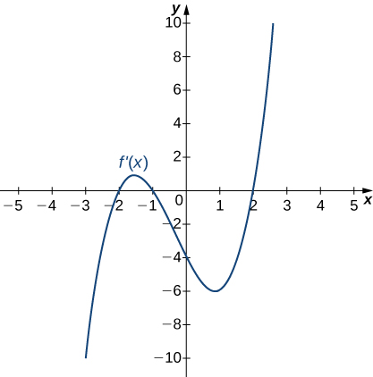

Answer: Increasing for  and decreasing for  and 

203.

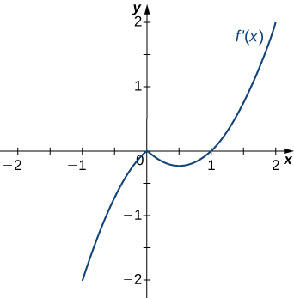

Answer: Decreasing for  increasing for 

205.

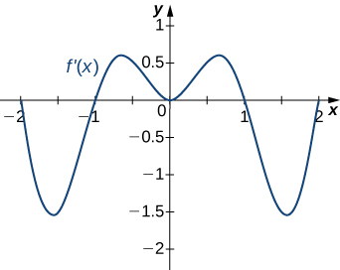

Answer: Decreasing for  and  increasing for  and  and 

**For the following exercises, analyze the graphs of then list all intervals where**

1. ** is increasing and decreasing and**
2. **the minima and maxima are located.**

207.

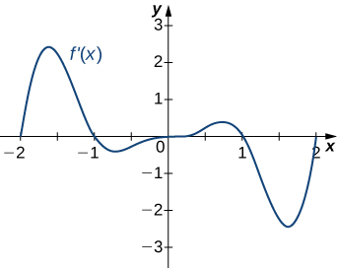

Answer: a. Increasing over  decreasing over b. maxima at  and  minima at  and  and 

209.

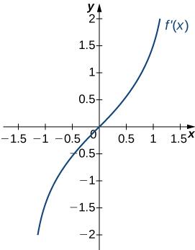

Answer: a. Increasing over decreasing over b. Minimum at

**For the following exercises, analyze the graphs of  then list all inflection points and intervals that are concave up and concave down.**

211.

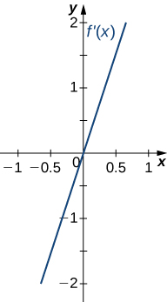

Answer: Concave up on all  no inflection points

213.

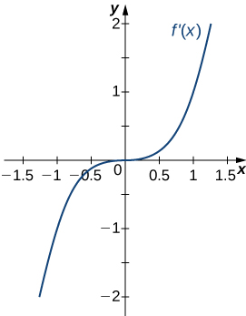

Answer: Concave up on all  no inflection points

215.

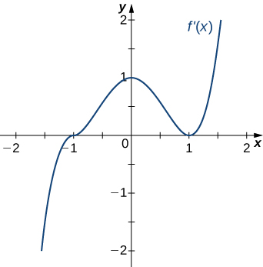

Answer: Concave up for  and  concave down for  inflection points at  and 

**For the following exercises, draw a graph that satisfies the given specifications for the domain  The function does not have to be continuous or differentiable.**

217.  over  over  for all 

Answer: Answers will vary

219. There is a local maximum at , local minimum at , and the graph is neither concave up nor concave down.

Answer: Answers will vary

**For the following exercises, determine**

1. **intervals where  is increasing or decreasing and**
2. **local minima and maxima of **

221.  over

Answer: a. Increasing over decreasing over  b. Local maximum at local minimum at

**For the following exercises, determine a. intervals where  is concave up or concave down, and b. the inflection points of **

223. 

Answer: a. Concave up for, concave down for  b. Inflection point at

**For the following exercises, determine**

1. **intervals where is increasing or decreasing,**
2. **local minima and maxima of **
3. **intervals where is concave up and concave down, and**
4. **the inflection points of **

225. 

Answer: a. Increasing over and , decreasing over b. Maximum at, minimum at  c. Concave up for concave down for  d. Infection point at

227. 

Answer: a. Increasing over and , decreasing over  b. Minimum at  c. Concave down for  concave up for  d. Inflection point at

229. 

Answer: a. Increasing over decreasing over  b. Minimum at  c. Concave up for all  d. No inflection points

**For the following exercises, determine**

1. **intervals where  is increasing or decreasing,**
2. **local minima and maxima of **
3. **intervals where  is concave up and concave down, and**
4. **the inflection points of  Sketch the curve, then use a calculator to compare your answer. If you cannot determine the exact answer analytically, use a calculator.**

231. **[T]**  over 

Answer: a. Increases over  decreases overand  b. Minimum at maximum at  c. Concave up for concave down for and  d. Inflection points at

233. **[T] ** over 

Answer: a. Increasing for all  b. No local minimum or maximum c. Concave up for  concave down for  d. Inflection point at

235. **[T] **

Answer: a. Increasing for all  where defined b. No local minima or maxima c. Concave up for concave down for  d. No inflection points in domain

237.  over 

Answer: a. Increasing over  decreasing over b. Minimum at maximum at  c. Concave up for concave down for d. Infection points at

239. 

Answer: a. Increasing over decreasing over  b. Minimum at  c. Concave up for concave down for  d. Inflection point at

**For the following exercises, interpret the sentences in terms of**

241. The population is growing more slowly. Here  is the population.

Answer: 

243. The airplane lands smoothly. Here  is the plane’s altitude.

Answer: 

245. The economy is picking up speed. Here  is a measure of the economy, such as GDP.

Answer: 

**For the following exercises, consider a third-degree polynomial which has the properties Determine whether the following statements are true or false. Justify your answer.**

247.  for some 

Answer: True, by the Mean Value Theorem

249. If has three roots, then it has  inflection point.

Answer: True, examine derivative

This file is copyright 2016, Rice University. All Rights Reserved.